In these Terms:
“Client Agreement” means the applicable terms and conditions and associated documents that govern your account with us;
“Deposit and Trade Requirements” means the requirements set out in clause 2.1 in these Terms;
“Eligible Client” means the requirements set out in clauses 1.1 & 1.2 of these Terms;
“Offer” means thus Reward offer, which is offered to you under these Terms;
“Pepperstone” “We” “us” “our” means Pepperstone Markets Limited (company number: 177174B);
“Pepperstone Pro” means a Professional Client as defined in our Terms and Conditions of Service; and
“Promotion Period” means on and from 8th December 2025 to 31st January 2026;
“Reward” refers to the Tmall e-Gift Card you will receive if you comply with these Terms;
“SCB” means Securities Commission of The Bahamas;
“Terms” means the Terms: and
“You” “Your” or “yours” means you, if you meet the criteria of an Eligible Client and the Deposit and Trade Requirements under these Terms.

1 The Reward
For you to receive your Reward:
1.1 You must comply with these Terms; and
1.2 You must:
- Have a live Razor or Standard trading account with Pepperstone;
- Be classified as a Pepperstone Pro;
- Reside in Mainland China;
- Fill out the form on the page to express the interest.

2 Deposit and Trade Requirements
2.1 Eligible Clients must meet the following Deposit and Trade Requirements during the Promotion Period:

Deposit Requirement (USD) | Trading Volume (Lots) | Reward
Min. $200 | FX: 5 Lots  Or  Commodities: 5 Lots | Tmall e-Gift Card valued at ¥100
$500 – $1,999 | FX: 20 Lots  Or  Commodities: 20 Lots | Tmall e-Gift Card valued at ¥500
$2,000 above | FX: 30 Lots  Or  Commodities: 30 Lots | Tmall e-Gift Card valued at ¥1000
* Lot size is generally 1 unit of the relevant currency per point.
2.2 For Eligible Client, once you meet the Deposit and Trade Requirements, we’ll send the Tmall e-gift card to your email account within 30 days.
2.3 The Reward per person or per household is capped at ¥1000 value of Tmall e-Gift Card. By participating in the Offer, you acknowledge and agree that the Reward are limited and will be allocated on a first-come, first-served basis. Becoming the Eligible Client does not guarantee receipt of the Reward. For confirmation of availability, please contact support.cn@pepperstone.com.
2.4 Trading volume will be calculated based on all Eligible Trades executed within the Promotion Period, regardless of when you express interest or become Eligible Client in this Offer or become a client of Pepperstone.
3 Eligible Trades
3.1 This Offer only applies to trades (“Eligible Trades”) in:
Forex pairs
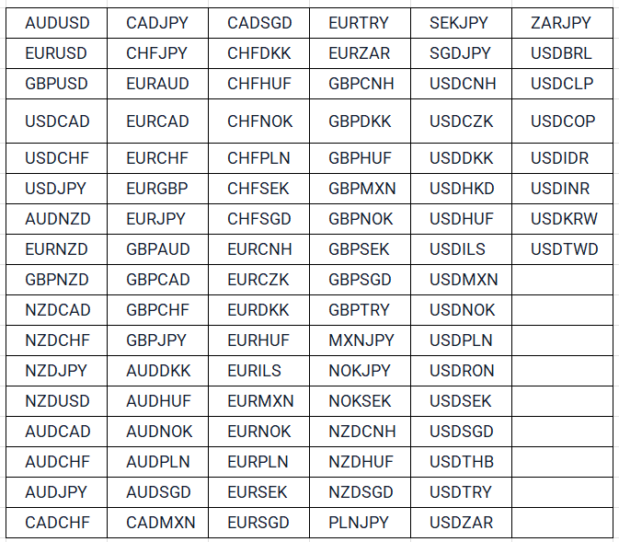

Commodities
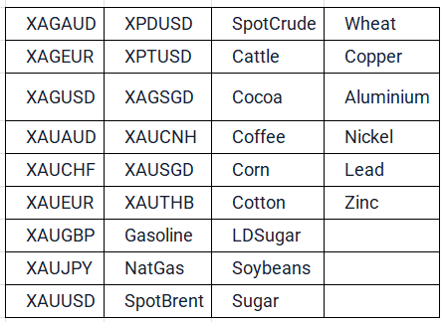
3.2 Products not displayed above aren’t eligible for this Offer unless otherwise agreed by a Pepperstone representative in writing.
3.3 You must place the Eligible Trades yourself and keep trades open for a minimum of 5 minutes and not hold hedged positions (opposing trades).
4 General
4.1 You must participate in this Offer in good faith. We reserve the right, at any time and in our sole discretion, to withhold any Reward awarded to you, exclude you from the Offer and/or suspend or permanently terminate trading account access for you, if you:
(a) breach any of these Terms or the applicable terms and conditions and our Client Agreement;
(b) engage in any actual or suspected abuse of this Offer; or
(c) we have reason to suspect that you have acted fraudulently or obtained an unfair or unintended advantage under this Offer.
4.2 Transfers between trading accounts with the same name do not meet the deposit requirements of this promotion. The Reward can’t be transferred to another person, another person’s trading account or exchanged for other goods and services.
4.3 This Offer is not available to Retail Clients.
4.4 This Offer is not available to clients that have previously engaged in market, finance or compliance actions that are inconsistent with our Client Agreement.
4.5 This Offer can only be claimed once per household.
4.6 You can’t claim this Offer for yourself via a joint account, company account of which you’re a director, a family member or a member of the same household.
4.7 4This Offer only applies to accounts opened with Pepperstone Markets Limited. A Reward will not be payable for any accounts opened with any other Pepperstone entities.
4.8 This Offer can’t be used in conjunction with any other Pepperstone promotion.
4.9 You acknowledge and agree that:
(a) The Reward are non-transferable and non-exchangeable, and no cash alternative is available. The Reward and its method of usage or redeem is subject to Tmall’s own terms & conditions.
(b) All taxes, which may be payable as a consequence of receiving the Reward, are the sole responsibility of the Participant.
(c) In the event that the Reward becomes unavailable for reasons beyond Pepperstone’s control, Pepperstone may substitute with another reward of equal or greater value.
4.10 We reserve the right to modify, change or withdraw this Offer at any time at our sole discretion. If we decide to withdraw this Offer, we’ll still honour the Offer in respect of all the Reward earned prior to the Offer being withdrawn, provided that you satisfy these Terms.
4.11 You acknowledge and agree that the Reward isn’t an inducement to trade, and we won’t be liable for trading losses incurred by you because of your trading or in relation to this Offer. Trading leveraged products involves a high degree of risk and you could lose substantially more than your initial investment.
4.12 You acknowledge and agree that the opening of a Pepperstone trading account is subject to the relevant anti-money laundering and counter-terrorism financing “Know Your Customer” checks under applicable anti-money laundering laws and that we can’t accept clients from jurisdictions on our banned countries list.
4.13 You acknowledge and agree that your participation in this Offer doesn’t make you our agent or representative.
4.14 This Offer is not open to residents of any jurisdiction participating in this Offer and would be contrary to local laws and regulations.
4.15 You are responsible for complying with all applicable laws and regulations in your country of residence that may apply to:
(a) your participation in this Offer; and/or
(b) your operation of a Pepperstone trading account.
4.16 We take our privacy obligations seriously. Please review our Privacy Policy for more information about how we handle your personal information.
4.17 These Terms are governed by the laws of The Bahamas and shall be subject to the jurisdiction of the courts of that country.

